Name:_______________________________________________ Date:________________ Period: _______

Physics (Regular) Test 2: Collisions & UAM (40 Points) Mr. Werman
Multiple Choice: Write the letter for the best answer in the space provided. (2 points each)
______1) The impulse experienced by an object is the same as the object’s change in:
a. velocity c. momentum
b. acceleration d. mass
______2) Which of the following scenarios BEST describes an object that is accelerating? (ignore friction and air resistance)
a. A bicyclist coasting on a flat road.
b. A bicyclist slowing down as it approaches an intersection.
c. A bicyclist coasting on a flat road after traveling down a large hill.
d. A bicyclist pedaling up a hill maintaining its speed.

_____3) An object moving in the +x direction experiences an acceleration of +2.0 m/s². This means the object
a. travels 2.0 m in every second.
b. is traveling at 2.0 m/s.
c. is decreasing its velocity by 2.0 m/s every second.
d. is increasing its velocity by 2.0 m/s every second.

______4) Which of the following situations is NOT possible?
a. An object is accelerating but has zero velocity.
b. An object has a velocity directed east and an acceleration directed west.
c. An object accelerates while maintaining a constant velocity.
d. An object is accelerating and has a changing velocity.
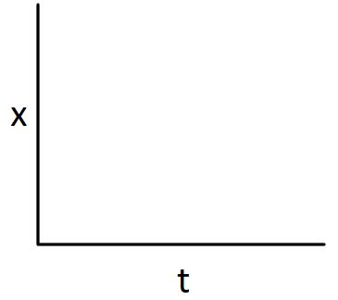

______5) Which of the following Position vs Time graphs would best describe a car moving in a positive direction and slowing down?



a. b. c. d.

6) In Game 1 of the 2024 World Series, Freddie Freeman hits a walk-off grand slam in the bottom of the 10th inning to win the game. The pitch was traveling at 43 m/s as it entered the hitting zone and exits his bat traveling at 52 m/s in the opposite direction. What was the magnitude of the impulse imparted on the 0.145 kg ball? (5 Points)

7) A car traveling at 20 m/s strikes an 80 kg bicyclist traveling in the same direction at 12 m/s. After the collision, the car is traveling at 19 m/s and the bicyclist is moving at 38 m/s. What is the mass of the car? (5 Points)

8) For a physics mini-lab, a student measures the time for a fan cart to travel from the 18 cm mark on a ruler to the 96 cm mark (starting from rest). Over three trials, the average time is measured to be 2.48 s. How fast would this same cart be traveling at the end of a 12 second test run? (5 Points)

9) During the SpaceX Flight 5 Test, the Super Heavy Booster falls with a constant terminal speed of 300 m/s when it lights its engines in preparation to be caught by the Mechazilla arms of the launch tower on the ground. It accelerates uniformly at a rate of 32 m/s², bringing it to rest for the catch.
a) What is the mass of the booster if the total impulse during this phase of the flight is 85,000,000 $\frac{kg∙m}{s}$? (4 pts)

b) How high above the tower is the booster when the engines ignited? (8 Pts)
c) Sketch the Position vs Time and Velocity vs Time graphs for the booster from the instant the engines fire through landing (Use the tower’s position as 0 m, with UP as the positive direction). (3 Pts)
***Write your answers on the lines at the bottom***

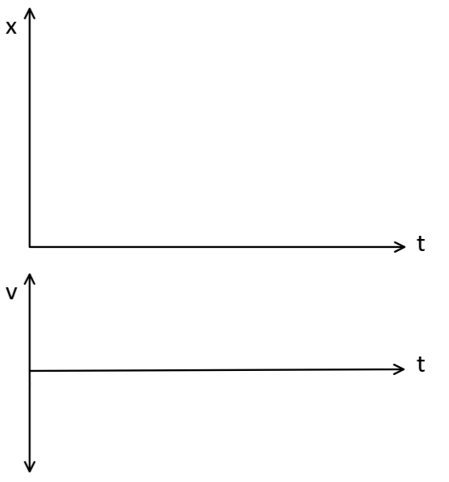

a) ____________________________________
b) ____________________________________

BONUS: (2 Points)

Two friends are playing a game of “capture-the-flag” on a paintball course. Dan shoots a 0.04 kg paintball at his opponent, striking him with a velocity of 40 m/s. Unfortunately, the paintball fails to rupture. Instead, it gives his opponent a 2.55 $\frac{kg*m}{s}$ momentum boost and bounces directly back toward Dan. What is the speed of the ball after impact?

A large 3 kg trashcan is at rest on some ice. Two hockey players stand side by side and each shoot 0.16 kg pucks that strike the can. The first puck hits with a speed of 20 m/s and the second with a speed of 30 m/s. Both pucks rebound directly back to the players with speeds of 5 m/s. How fast is the trashcan moving afterwards?

PICK 3 of the next 4 Questions:



16) An astronaut finds himself stranded 5 m away from his spaceship with only a hammer in his tool belt. The astronaut pulls out the hammer and throws it in the opposite direction from the spaceship at 18 m/s. The astronaut with all their gear (including the hammer) has a mass of 100 kg and the hammer is 2 kg of that mass. (Assume the astronaut is rest relative to the spaceship before throwing the hammer)
a) Graph the motion of the astronaut AND hammer on the axes below (label each). Use a SOLID line for the astronaut and a DASHED line for the hammer. The position of the spacecraft should be at zero on your Position vs Time graph and the direction of the hammer throw is the POSITIVE direction. Use the dotted line on the graph to represent the time the hammer is released. (4 Points)
b) How long will it take the astronaut to reach the ship after the throw? (10 Points)



18) The WEXP video crew is testing a new flying video drone. Starting from rest, it takes off vertically from the ground with a uniform acceleration of 6 m/s². When it reaches an altitude of 30 m, the motor abruptly cuts off and no longer provides an upward thrust. Without power, gravity slows the drone at a rate of 10 m/s² as it continues climbing to its max altitude.

a) Sketch the Position vs Time and Velocity vs Time graphs for the drone from launch to peak. (4 Points)

b) What was the max altitude of the drone during the flight? (10 Points)



Make-up Problems
$$\left(1\right) x_{f}=\frac{1}{2}at^{2}+v_{i}t+x_{i} \left(2\right) v_{f}=at+v_{i} \left(3\right) v_{f}^{2}=v_{i}^{2}+2a\left(x_{f}-x_{i}\right)$$
$$p=mv J=∆p=p_{f}-p_{i}$$
1) When the traffic signal turns green, a car accelerates from rest for 6.4 s at 1.2 m/s². The driver then applies the brakes, bringing the car to rest at a rate of 1.8 m/s².

a) Sketch the Position vs Time and Velocity vs Time graphs for the drone. (4 Points)

b) What was the total distance traveled by the car? (10 Points)



2) A 0.8 kg fan cart starts at rest and accelerates to the right at 0.6 m/s² for 3 seconds before colliding with a second cart with half the mass traveling left at 0.25 m/s. The two carts stick together and continue moving. (Assume the fan stops running after the collision with the carts moving at constant velocity)
a) Sketch the Position vs Time and Velocity vs Time graphs for the two carts. Use a SOLID line for the fan cart and a DASHED line for the second cart. Use the dotted line on the graph to represent the time of the collision. (4 Points)
b) What is the speed of the carts after the collision? (10 Points)



3) A car is traveling at 30 m/s on the highway when a deer jumps into the road. The driver sees the deer and takes 0.8 s to react and apply the brakes (the car continues to move during this time). Once the brakes are applied, the car skids to a stop, slowing at a constant rate of 6 m/s², avoiding a collision with the deer by the narrowest of margin.

a) Sketch the Position vs Time and Velocity vs Time graphs for the car starting from the time the driver sees the deer enter the road. (4 Points)

b) How far away was the deer from the car when it entered the road?
(10 Points)



4) Grandma decides she wants to participate in some recreational clay shooting with her sons. Sitting in her wheelchair, she aims the shotgun and fires. Unfortunately, her sons forgot to put on the parking brake, allowing her to roll backwards towards the edge of the shooting platform due to the recoil. The total mass of grandma, the chair, and shotgun is 60 kg and the 0.05 kg shotgun shell leaves the gun at 500 m/s. (Assume grandma is rest when she fires the shot)
a) Graph the motion of grandma AND the shotgun shell on the axes below (label each). Use a SOLID line for grandma and a DASHED line for the shell. The edge of the platform should be at zero on your Position vs Time graph and the direction she fires is the POSITIVE direction. Use the dotted line on the graph to represent the time the shot is fired. (4 Points)
b) 3 seconds after firing, she rolls off the platform. How far away from the edge was she when the shot was fired? (10 Points)



______5) Which of the graphs represent an object having zero acceleration (Make note of the axis labels…there is a mix of Position vs Time and Velocity vs Time graphs)?

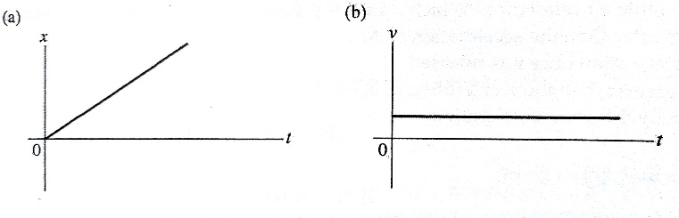
v
v
v
x

IV
III
II
I

a. only graph I
b. only graph II
c. graphs II and III
d. graphs III and IV
e. graphs I and II

